A REPORT ON THE IMPACT OF WFNR IN THE LAST YEAR
REPORT FROM THE OFFICE OF THE WFNR SUB-SAHARAN AFRICA REGIONAL VICE PRESIDENT - PROF MAYOWA OWOLABI MBBS, MSc, DM, FAAN, FANA, FAS, FAMedS, FAAS, FRCP
The Regional Vice-president of the World Federation for Neurorehabilitation, Professor Mayowa Owolabi has continued to promote the ideals of the WFNR in the sub-Saharan African region which he oversees. Despite the COVID-19 pandemic, Blossom Centre, a foremost institution across the sub-Saharan Africa continent, under the leadership of Prof Mayowa Owolabi, had over the years and currently, continued to pioneer excellent research, training, advocacy and efficient individualised services in neurorehabilitation. The following activities lends credence to the pursuit of this mandate in the last one year:

- CAPACITY BUILDING ACTIVITIES: JOINT WEBINAR - NIGERIAN FEDERATION OF NEUROREHABILITATION (NFNR)-WORLD FEDERATION FOR NEUROREHABILITATION (WFNR)-AFRICAN STROKE ORGANIZATION (ASO)
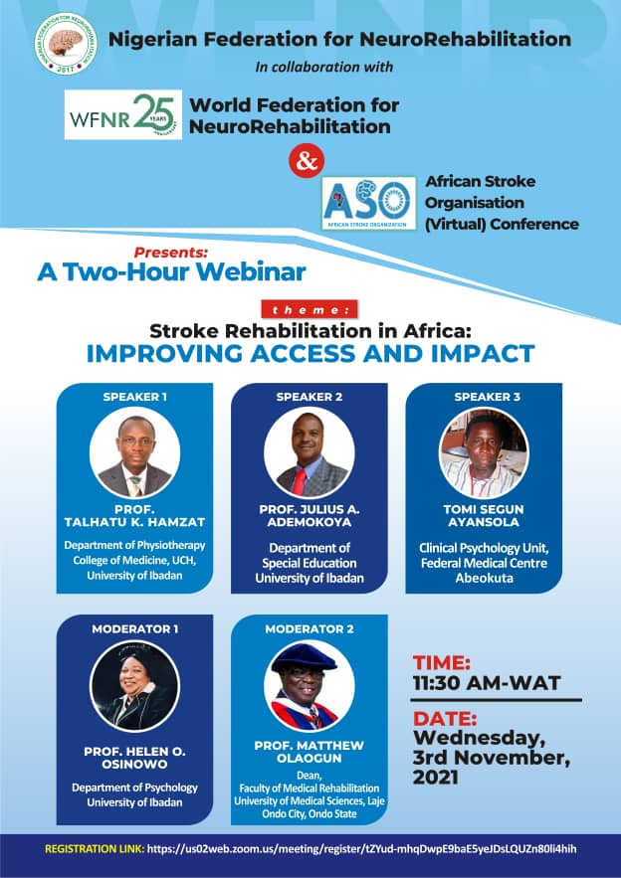
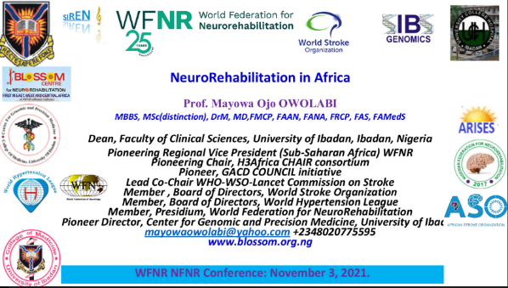
The Nigerian Federation of NeuroRehabilitation (NFNR), an affiliate of the World Federation of NeuroRehabilitation (WFNR) in its fourth year hosted a Webinar on the first day of the African Stroke Organization (Virtual) Conference (ASOC) on Wednesday, November 3rd, 2021, from 11 a.m. to 1 p.m. Nigerian time. The ASO conference was held in commemoration of the 25th Jubilee of the WFNR. The webinar titled ‘Stroke Rehabilitation in Africa: Improving Access and Impact’, had as facilitators, three erudite scholars drawn from the field of neuro-physiotherapy, speech therapy and neuro-clinical psychology amidst other moderators. As one of the Vice-Chairs of NFNR, Prof Mayowa Owolabi in his welcome presentation on Neurorehabilitation in Africa, he highlighted the various capacity-building activities of the NFNR and some of the collaborative activities in this regard with the WFNR Flying faculty.
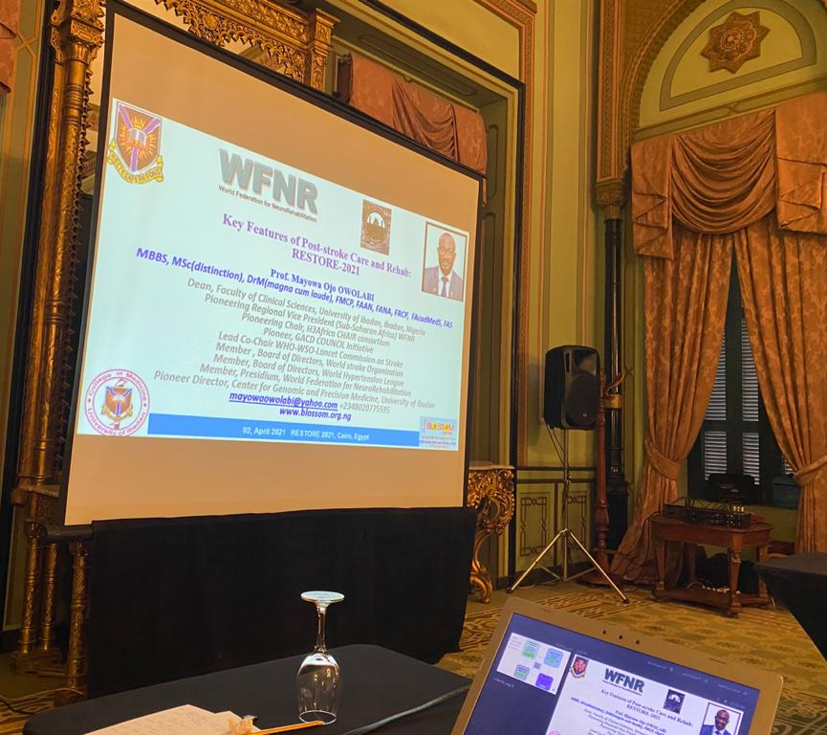
- PRESENTATIONS AND PARTICIPATION IN AFRICA NEUROREHABILITATION DEMONSTRATIVE PROGRAMME (NEURO) REHAB ‘RESTORE 2021’ POST STROKE CARE PROGRAM.
A one-day Neuro-Rehab teaching course tagged RESTORE 2021 was organised and endorsed by WFNR in the African continent. This meeting which took place at TOLIP Hotel Alexandria in Egypt, with both physical and virtual participation format, had erudite members (from speech, physical and neurology departments) of the WFNR in attendance including the RVP SSA, Prof Mayowa Owolabi. In his virtual presentation titled, ‘Key features of post-stroke care and rehabilitation program’, he highlighted the role of Stroke quadrangle across the life course as well as the goal of rehabilitation to maximise quality of life.
- PRESENTATIONS AND PARTICIPATION IN ASIAN OCEANIA NEUROREHABILITATION ACTIVITIES

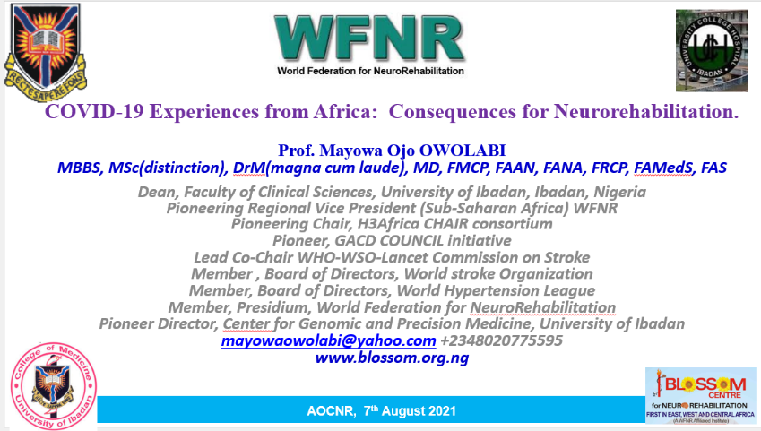
Prof Owolabi participated in the Asian Oceania Conference on Neurorehabilitation (AOCNR 2021) tagged Community Based Rehabilitation: Role for Neurorehabilitation and conditions in different Asian Oceanian Countries which took place in August 6th – 7th 2021 virtually. In his presentation, Prof Owolabi highlighted some community-based research (CBR) experience from Nigerian perspectives during this meeting on the 7th of August. In his remarks he highlighted various rehabilitation episodes that should be identified and structured to deliver appropriate care to stroke patients through the course of patient’s recovery after stroke. Further, in his words during his presentation titled COVID-19 Experiences from Africa: Consequences for Neurorehabilitation', he stated that “In Africa, curbing COVID-19 is a marathon and not a sprint.” Further, about16 countries in sub-Saharan Africa (SSA) have improved their capacity to respond to COVID-19 including coordination, surveillance, laboratory capacity, case management, infection prevention and control
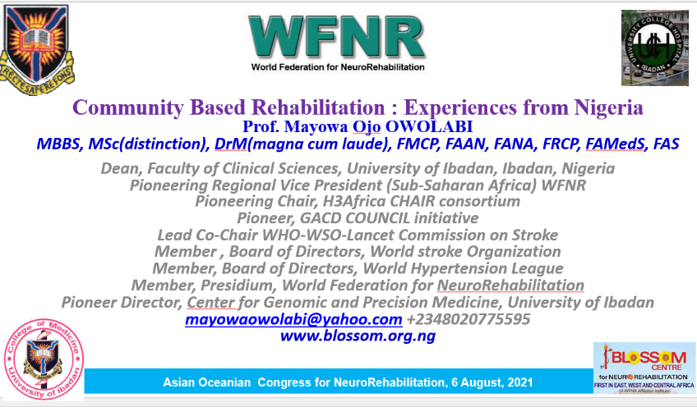

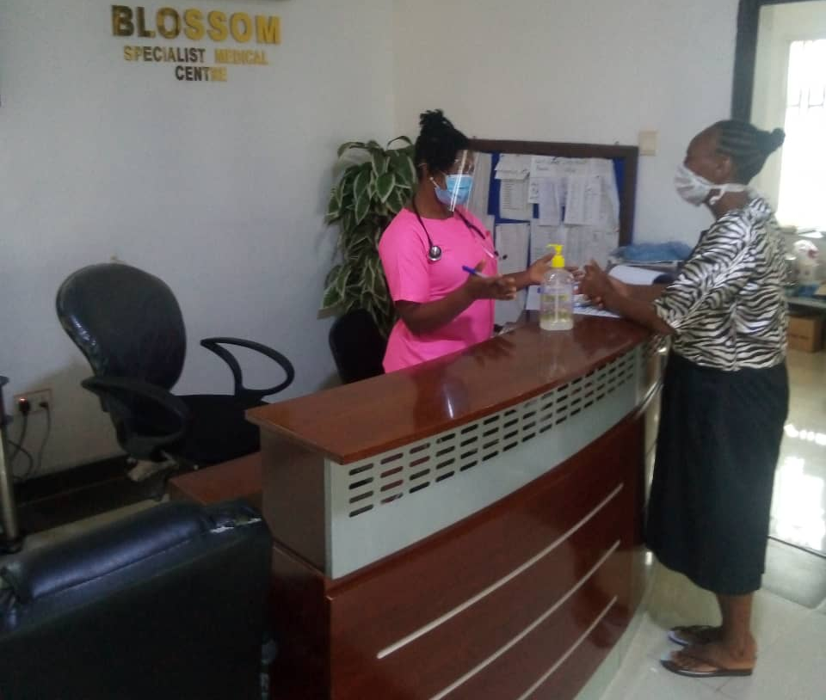
- NEUROREHAB SERVICE PROVISION: Blossom centre had remained resolute in its vision of providing holistic and integrative rehabilitative healthcare services for all neurological cases referred from and across Nigeria and other sub-Saharan African countries. Though this vision suffered a temporary setback due to the COVID-19 pandemic, the centre has picked up in service delivery given the lifting of travel restrictions by the Federal Government of Nigeria. Despite the COVID-19 pandemic and its recent variants, excellent patient-centred neurorehabilitation services have been provided to a minimum of 105 stroke cases in 2021 with at least 80% success rate and a score of continuous treatment for recurring cases. This has translated to a better quality of life for its clientele base of over 1000 patients and counting.

- Additional Global Neurorehabilitation Initiatives: Prof Owolabi is currently involved in some notable, global some of which includes WHO Rehabilitation 2030 … package of interventions for Parkinson's Disease and Dementia, and One Neurology.

